Exercise 5

Calculate V(0) for circuit 5. Simulate in MultiSim to verify calculations at omega = 1 rad/s. First show the AC circuit, then the calculated, and finally the MultiSim verification.

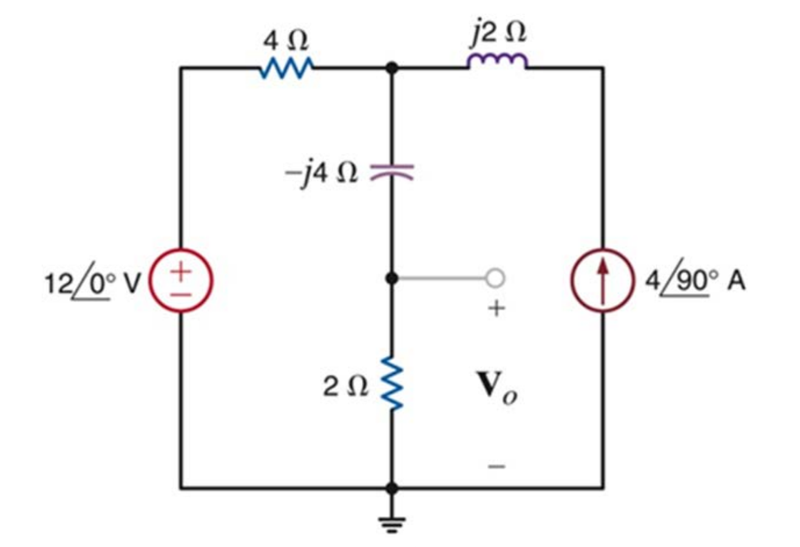

Circuit 5 for exercise 5

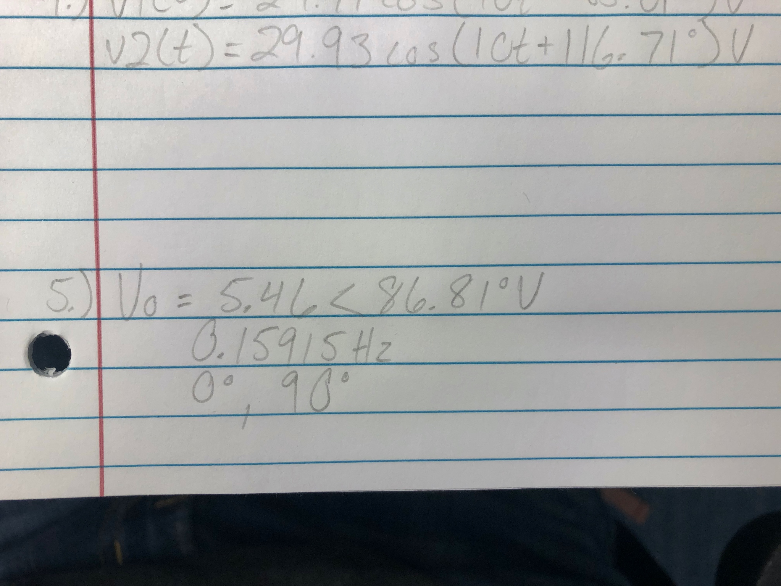

Final equation for exercise 5

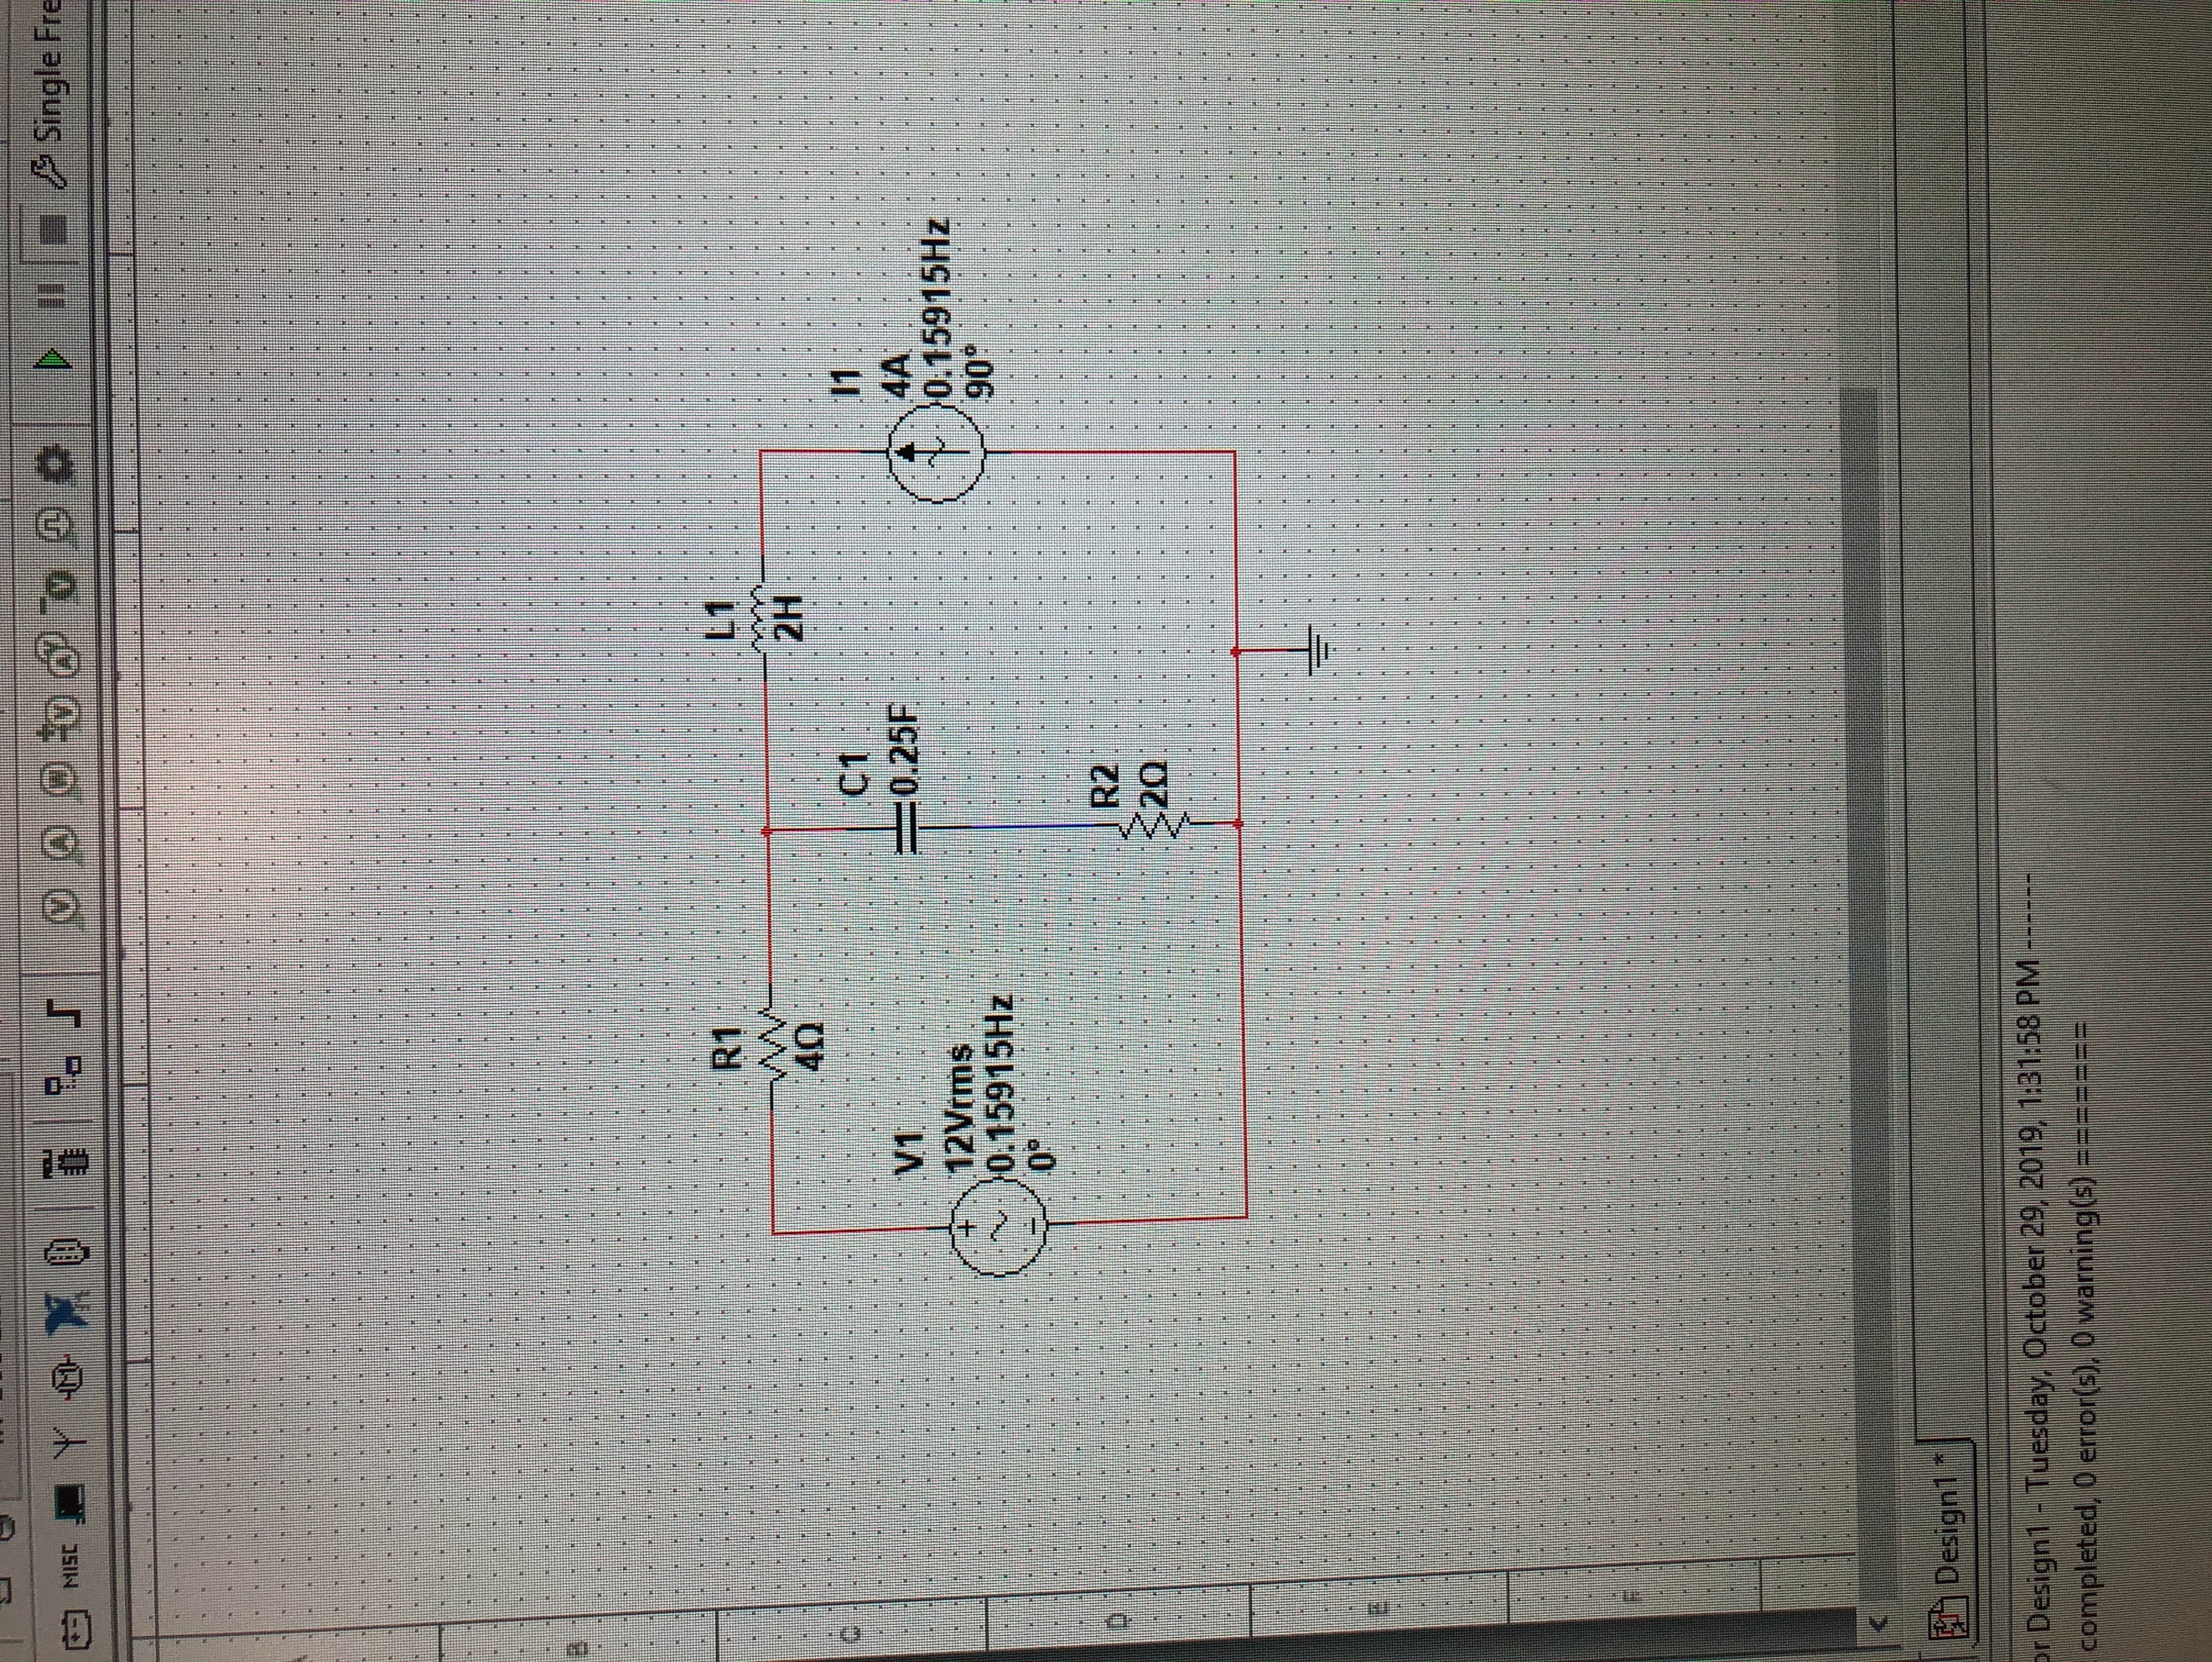

MultiSim circuit exercise 5

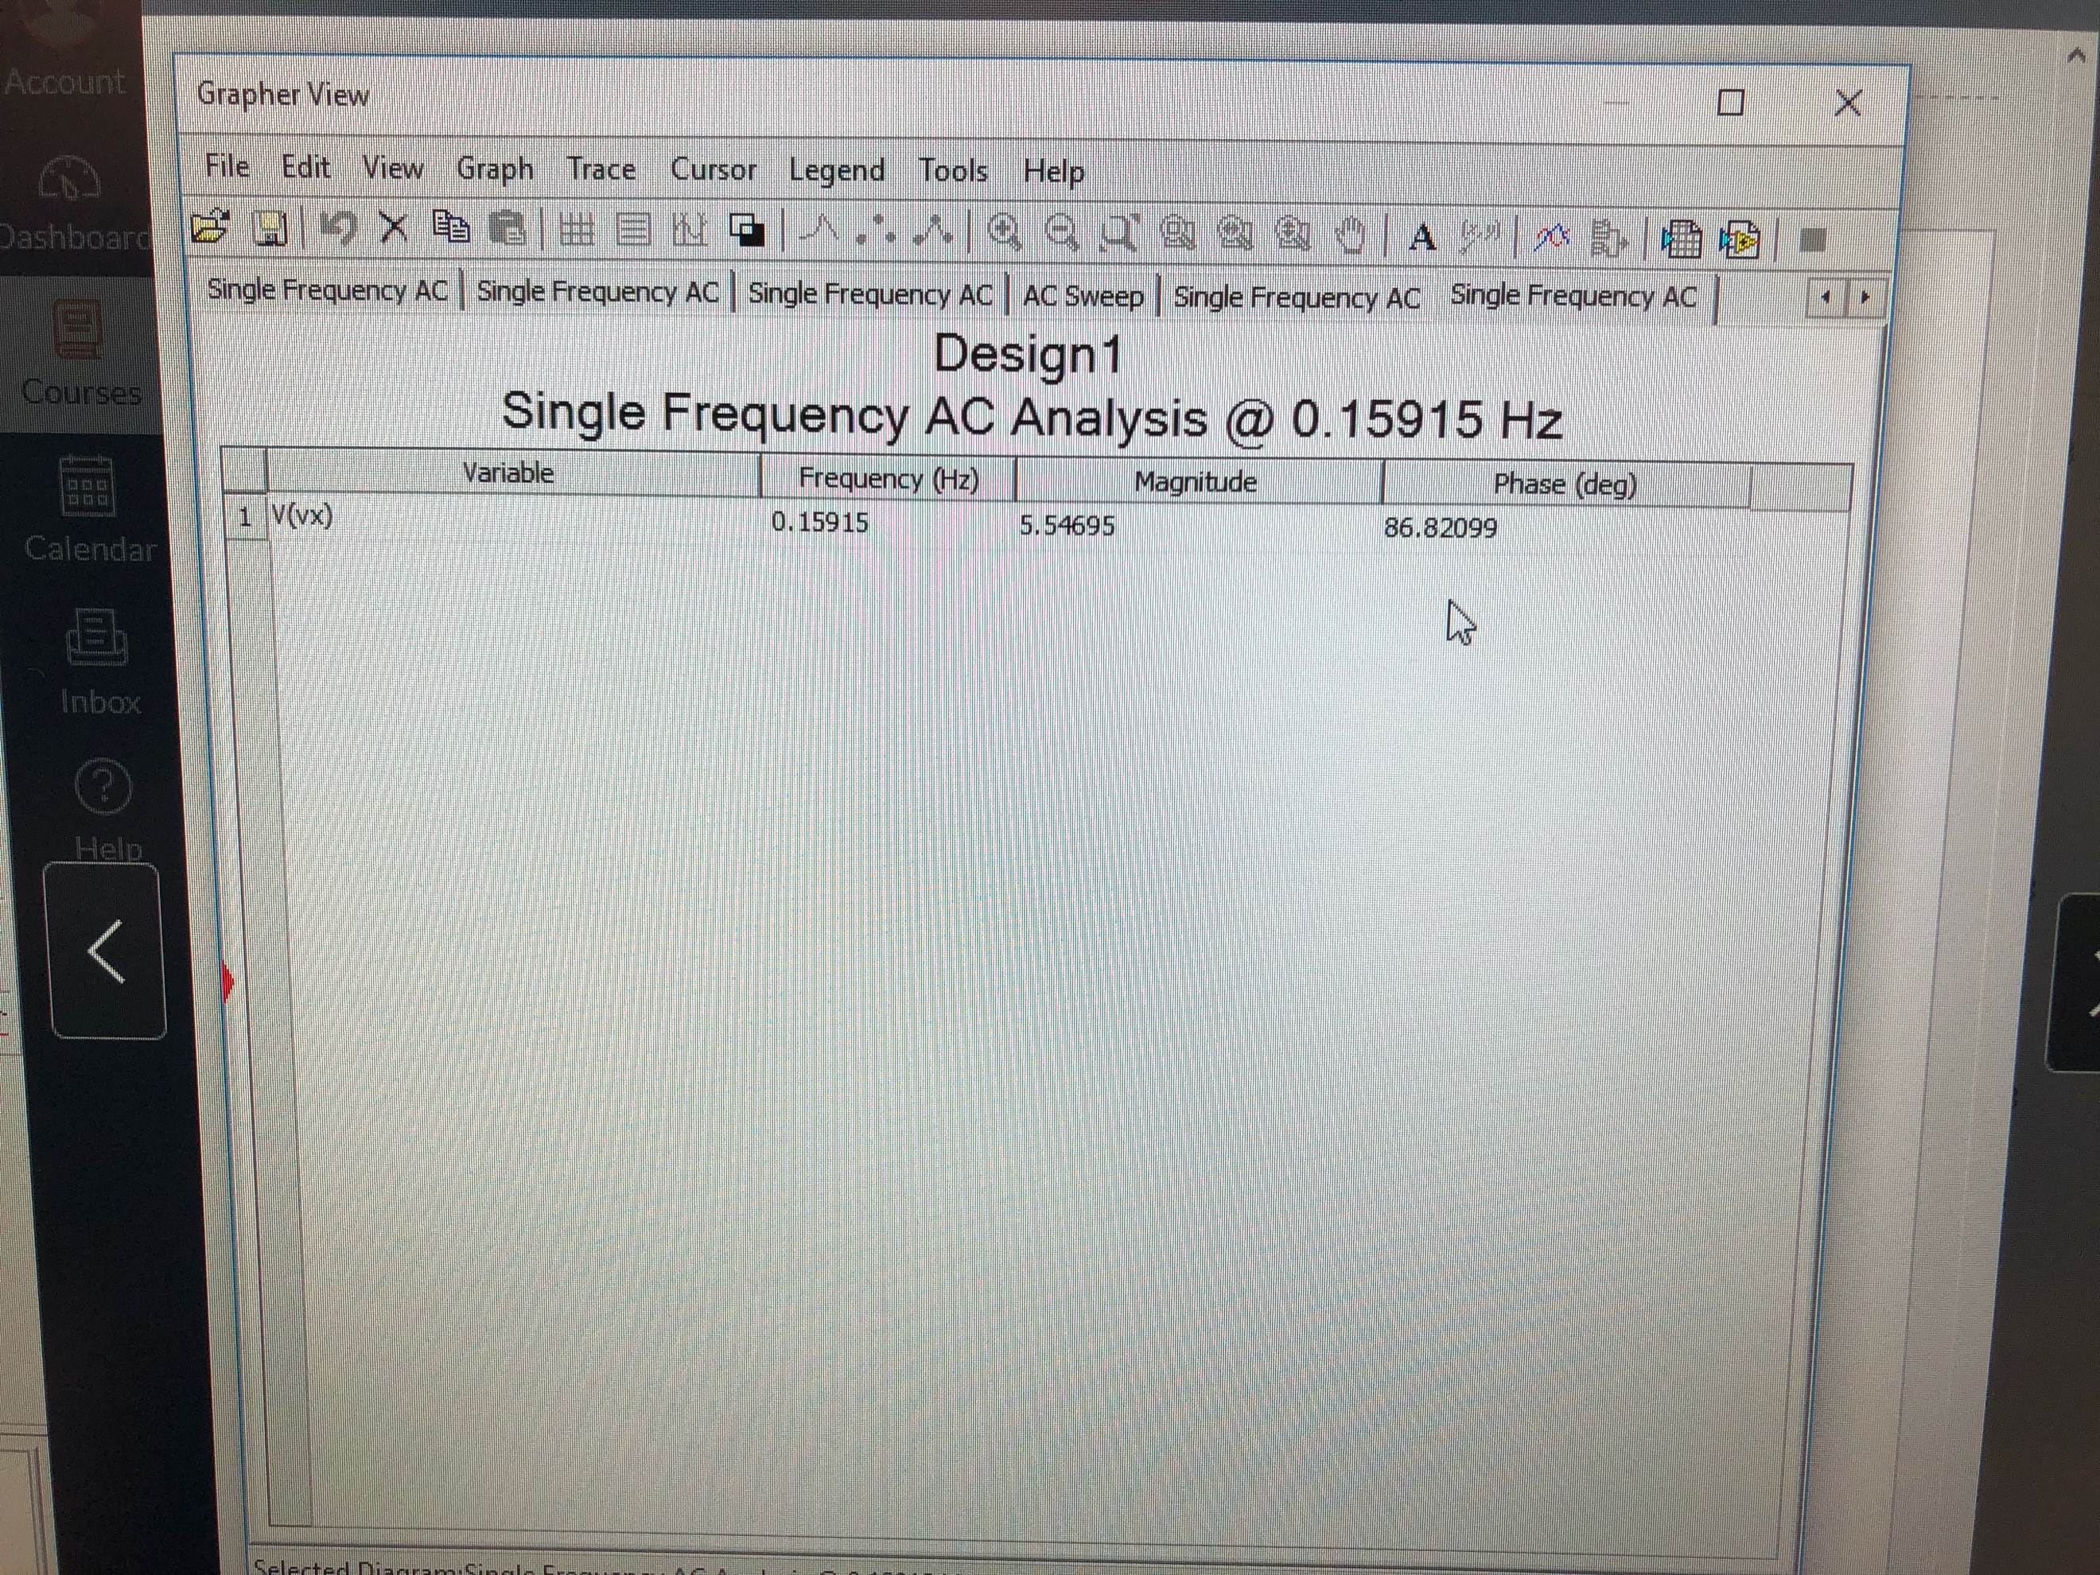

AC Sweep

|  |  |  |  |
| --- | --- | --- | --- |
| **Variable** | **Frequency (Hz)** | **Magnitude** | **Phase (degrees)** |
| V(t) | 0.15915 | 5.547 | 86.821 |

Conclusion

Lab 9 was based on switching everything learned previously in this course to AC circuits. I first found the calculated values for exercise 5, and then used MultiSim to verify those answers. Using a virtual circuit, I ran a virtual Single frequency AC analysis to get exact answers compared to my equations. This was very helpful in making sure the equations came out correctly.